Day 2 - Assignment

1.Draw a labelled diagram of a typical home WiFi router and a network switch, clearly marking at least 3 different ports (such as WAN, LAN, Console) and the location of status LEDs.
Ans:

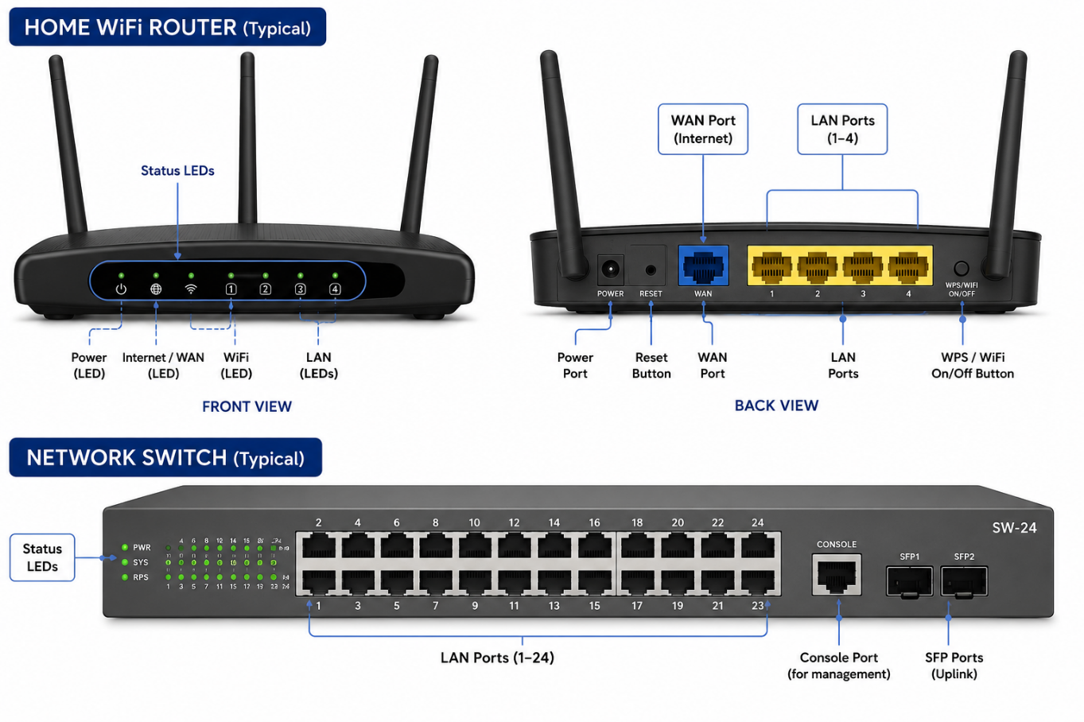

2.List 3 key differences between routers and switches in terms of their main functions and how they handle network traffic.<br><br><em><strong>Hint:</strong> Think about how each device deals with IP addresses, MAC addresses, and the types of networks they connect.</em>
Ans:

Feature | Router | Switch
Main Function | Connects different networks (e.g., your home network to the Internet). | Connects devices within the same local network (LAN).
Traffic Handling | Uses IP addresses to decide the best path and route data between different networks. | Uses MAC addresses to forward data directly to the correct device within the same network.
Network Type | Connects multiple networks such as LAN to WAN (Internet) and separates broadcast domains. | Connects devices on a single LAN, allowing PCs, printers, and servers to communicate efficiently.

3.Take a real or virtual image of a router and a switch (from your home, lab, or Google Images), and identify the following on each: Power port, at least 2 Ethernet ports, and any LED indicators. Annotate the image or describe their position and purpose.
Ans :
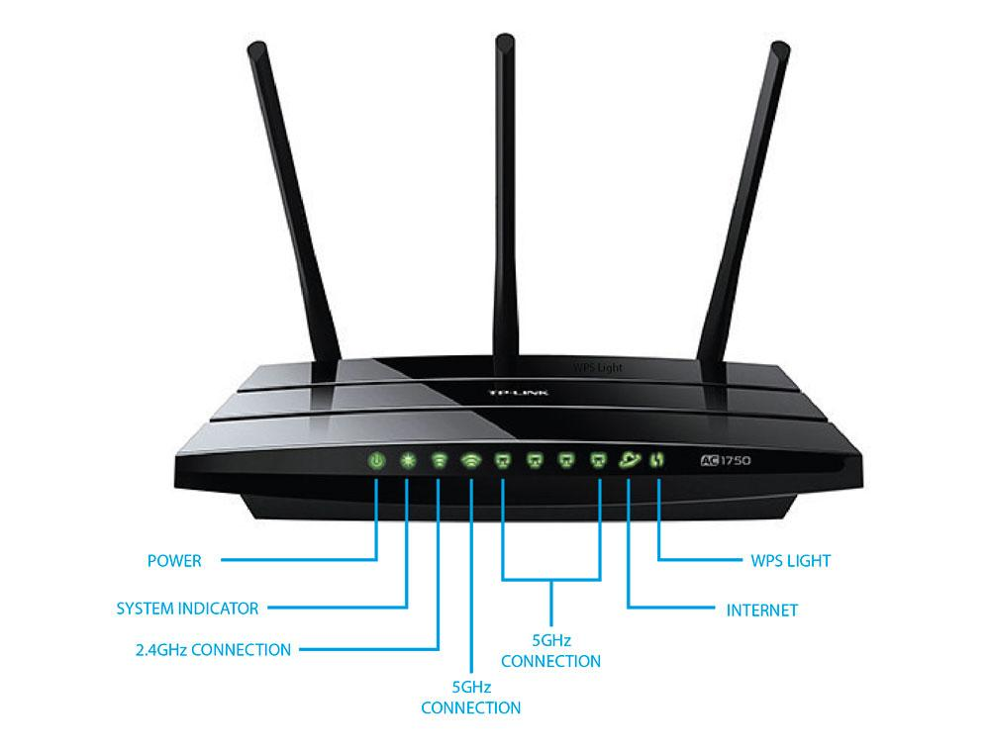

1. WiFi Router (Typical)
Power Port
- Position: Back panel, usually at the far left.
- Purpose: Connects the power adapter to supply electricity to the router.
Ethernet Port 1 – WAN (Internet)
- Position: Back panel, usually a blue or differently colored RJ-45 port.
- Purpose: Connects the router to the modem or Internet service provider (ISP).
Ethernet Port 2 – LAN
- Position: Back panel, next to the WAN port (usually yellow).
- Purpose: Connects wired devices such as a desktop PC, laptop, switch, or smart TV.
LED Indicators
- Position: Front panel or top of the router.
- Purpose:
  - Power LED: Indicates the router is powered on.
  - Internet/WAN LED: Shows Internet connection status.
  - WiFi LED: Indicates wireless network is enabled.
  - LAN LED: Blinks when data is being transmitted through LAN ports.

2. Network Switch (Typical)
Power Port
- Position: Rear panel or one side of the switch.
- Purpose: Supplies power to the switch.
Ethernet Port 1
- Position: Front panel (Port 1).
- Purpose: Connects a computer, printer, or other network device.
Ethernet Port 2
- Position: Front panel (Port 2 or any other numbered port).
- Purpose: Connects another network device or provides an uplink to another switch/router.
LED Indicators
- Position: Front panel beside or above the Ethernet ports.
- Purpose:
  - Power LED: Indicates the switch is powered on.
  - Link/Activity LED: Lights up when a device is connected and blinks during data transmission.
  - Speed LED (if available): Indicates the connection speed (10/100/1000 Mbps).
These labels and descriptions are suitable for a lab report if you are using either real hardware or reference images from a networking lab or manufacturer documentation.

4.Imagine you are setting up a small gaming café network for IPL streaming and multiplayer matches. Write a short scenario explaining which device (router or switch) you would connect first to the ISP line, and how you would connect 8 gaming PCs to the network. Justify your choices.
Scenario: Small Gaming Café Network Setup for IPL Streaming and Multiplayer Matches
I am setting up a gaming café with 8 gaming PCs where customers will watch IPL live streams and play multiplayer games such as Valorant, PUBG, or FIFA.
Network Setup
Connection Order
Recommended
ISP Internet Line
Incoming connection from the service provider
Router
Connected first to the ISP line
Network Switch
Connected to a LAN port of the router
PC1
PC2
PC3
PC4
PC5
PC6
PC7
PC8
All PCs connected to the switch using Ethernet cables
Why connect the router first?
The router must be connected directly to the ISP line because it:
- Receives the public Internet connection from the ISP.
- Performs NAT (Network Address Translation) so multiple PCs can share one Internet connection.
- Provides DHCP, automatically assigning IP addresses to the gaming PCs.
- Offers basic firewall and security protection for the café network.
Why use a switch for the 8 PCs?
After the router, I would connect a gigabit network switch to one of the router's LAN ports.
The switch is ideal because it:
- Provides enough Ethernet ports for all 8 gaming PCs.
- Forwards traffic using MAC addresses, allowing fast communication between PCs.
- Reduces unnecessary traffic by sending data only to the correct device.
- Supports high-speed local multiplayer gaming with low latency.
Justification
Device | Reason
Router | Connects to the Internet, assigns IP addresses, and provides security.
Switch | Connects all 8 PCs and enables fast local network communication.
Final Design
Best for a small café
The best design for this café is:
ISP
Router
Switch
8 Gaming PCs
This setup ensures stable IPL streaming, low-latency multiplayer gaming, and easy expansion if more PCs are added later.

